**Problem 1768 . Merge Strings Alternately**

Problem link

https://leetcode.com/problems/merge-strings-alternately/description/?envType=study-plan-v2&envId=leetcode-75

**Final code:**

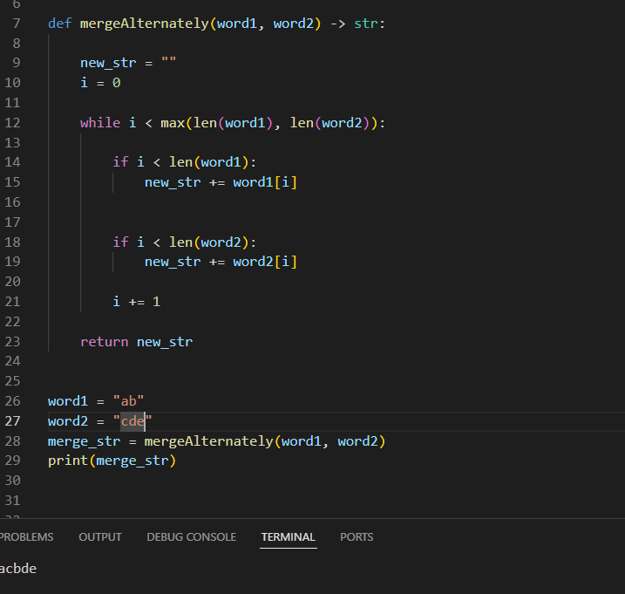

**LIST AND SET:**

**Remember :**

Set is more faster then list I.e set has Faster Lookups (O(1) Time Complexity)

### 📌 Example:

If you're doing many lookups (like in this problem where you're checking every character), set will perform much faster than a list.

vowels = set('aeiouAEIOU')

Vowels = {‘a’, ‘e’ ….}

#### list:

1. A list in Python is an **ordered collection**.
2. When you do 'i' in my_list, Python has to **check each element one by one** until it finds a match.
3. Worst-case: it checks **every item** → O(n) time.

#### set:

A set is an **unordered collection with unique elements**, implemented using a **hash table**.

When you do 'i' in my_set, Python:

1. Computes a **hash** of 'i'.
2. Looks up that hash in constant time.
3. So it's typically **much faster**, especially when the set has many elements.